Abstract Submission Form
Guideline
1. Fill up all ALL the sections below in this form. Incomplete form will not be entertained.
2. Submission deadline is 10 June 2026.
3. Strictly follow the instruction and write according to the word limit given.
4. Submit your abstract via email to info@amsc.com.my & garychai@thedeltus.com to be reviewed by AMSC Scientific Committee.
5. Status of your submission will be notified by 26 May 2026 (only if it’s not approved). Else the Organizer shall print the approved abstract in poster form to be displayed at the exhibition area.
6. Abstracts must include sufficient information for reviewers to judge the nature and significance of the topic, the adequacy of the investigative strategy, the nature of the results, and the conclusions.
7. The abstract should summarize the substantive results of the work and not merely list topics to be discussed. An abstract is an outline/brief summary of your paper and your whole project.
8. It should have an intro, body and conclusion. It is a well-developed paragraph, should be exact in wording, and must be understandable to a wide audience.
9. Abstracts should be no more than 250 words, formatted in Microsoft Word, and single-spaced, using size 12 Times New Roman font.
10. Highlight major points of your research and explain why your work is important; what your purpose was, how you went about your project, what you learned, and what you concluded.
11. If your title includes scientific notation, Greek letters, bold, italics, or other special characters/symbols, do make sure they appear correctly.
12. List all additional undergraduate co-authors, whether they are or are not presenting, if applicable.

Terms & Conditions
1. Abstracts should report on completed research, not ongoing investigations. The Scientific Committee reserves the right to make minor corrections in the submitted abstracts.
2. Abstracts will only be included in the event if the presenting author is a participant of the AMSC with complete submission made before 10 June 2026.
3. The format of abstract presentation will be in printed and/or e-poster (on www.amsc.com.my) form and shall be decided by the Scientific Committee. Results of the selection process will be sent via e-mail to the corresponding author. The Committee decision is final. Printed poster will be displayed at AMSC Malaysia 2026 posters area (Exhibition Hall), at Kuala Lumpur Convention Center (KLCC) Level 3 on 13 & 14 August 2026.
4. Abstracts must be written in English.
5. Abstract submitted must NOT been presented at a major international meeting prior to the AMSC Malaysia 2026. An update to prior study is acceptable.
6. Size of poster will be A0.
7. Submission of an abstract indicates:
- that the author(s) agree to comply with the abstract submission and presentation rules.
- that the presentation is based on ethical and valid scientific and/or clinical methods.
- that all authors have contributed to and approve the abstract and its entire contents.
8. Abstract evaluation criteria, include the following:
- Scholarly and/or research validity
- Educational value
- Clarity of presentation
- Potential impact on global dermatology / aesthetic medicine
9. For CLINICAL OR INVESTIGATIVE STUDIES, it shall include :
- Introduction, Objectives, Materials and Method, Results, Conclusions (and reference image(s) / graph / chart if any)
10. For CASE REPORTS OR CASE SERIES, it shall include :
- Background, Observation, Key message (and reference image(s) / graph / chart if any)

Please fill in accordingly (or to create / design a complete poster with images, to be submitted in PDF file) :

Abstract Title:

Author and / or Co-Author’s details:

Abstract (NOTE : Maximum 250 words) :

REFERENCE
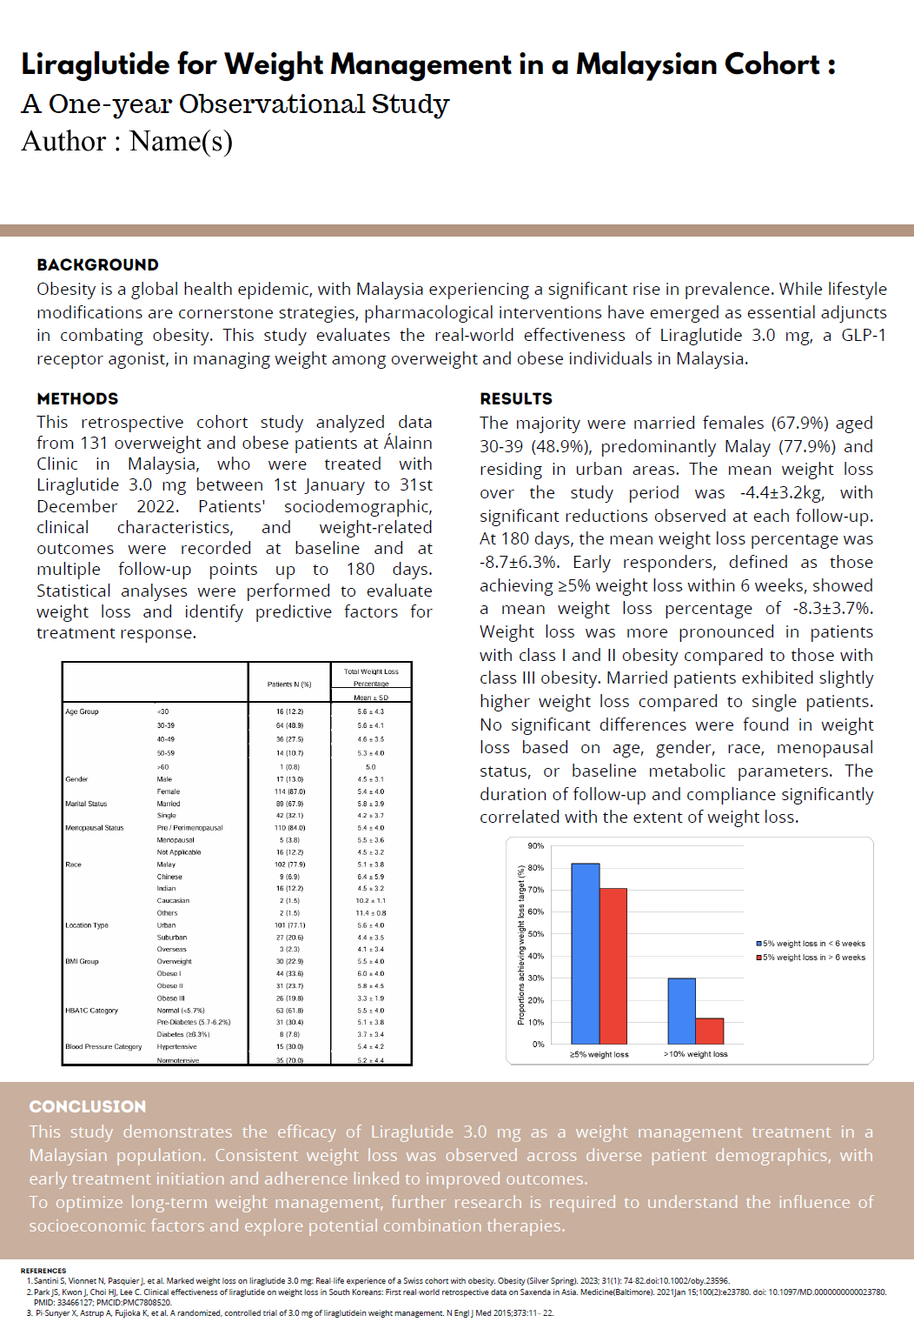

Has this abstract been made and presented in any other conference before?
☐ Yes
☐ No

Remarks
1. Kindly email this completed form via email to info@amsc.com.my & garychai@thedeltus.com
2. You will be notified upon your abstract has been reviewed by the Scientific Committee by 26 May 2026.
3. Only common and standard abbreviations may be used without definition, no references, tables, charts, or images are allowed.
4. Please ensure that abstract submitted is checked thoroughly for grammatic and spelling errors. The Scientific Committee does not responsible to correct any of the above said errors (if any).
5. Drugs, devices, products, and services should be identified by generic name only. The use of commercial drug names, brands and registered trademarks are prohibited. No mention of pharmaceutical company names should be included in the abstract.
6. Data must be given in units (International metric system is preferred) that are generally accepted in scientific publications.
7. All co-authors must agree with the submitted results and conclusions, and consent to being listed as authors.
8. Work involving humans or animals, or material derived from them must have been approved by an institutional ethics committee.

Thank you for your interest in submitting abstract for
Aesthetic Medicine & Surgery Conference & Exhibition (AMSC) Malaysia 2026
See you in AMSC Malaysia on 13 & 14 August 2026 at the
Kuala Lumpur Convention Center (KLCC) Level 3, Malaysia

